**CP Club 365 Days Challenge**

**Programming language – Python**

**Problem Statement**

[https://practice.geeksforgeeks.org/problems/find-transition-point-1587115620/1?page=2&difficulty[]=0&sortBy=submissions](https://practice.geeksforgeeks.org/problems/find-transition-point-1587115620/1?page=2&difficulty%5b%5d=0&sortBy=submissions)

**Your Code**:

# 0x93Day of 0x365Days challenge

# VEDANT BHARAD

# 18-1-2023

def transitionPoint(arr, n):

    if 1 in arr:

        return arr.index(1)

    return -1

#{

 # Driver Code Starts

#driver code

if __name__=='__main__':

    t=int(input())

    for i in range(t):

        n = int(input())

        arr = list(map(int, input().strip().split()))

        print(transitionPoint(arr, n))

# } Driver Code Ends

**Output (Screen Shot)**:

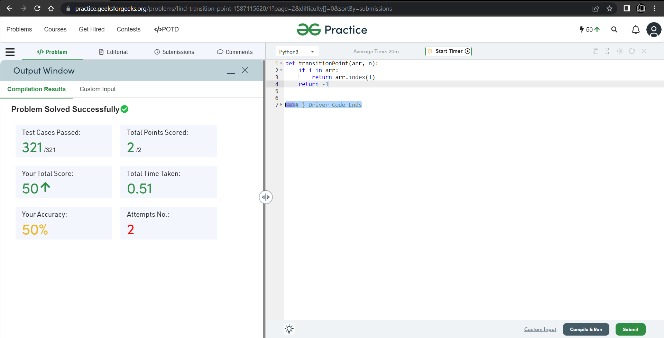

**Understanding about problem:**

* In this task I need to return index form where value of array change 0 to 1 if no change then return -1.

Note: If you can't understand the problem, feel free to contact us and we'll help you. Please don't copy and paste from anywhere.

ALL THE BEST

Team CP Club